1.

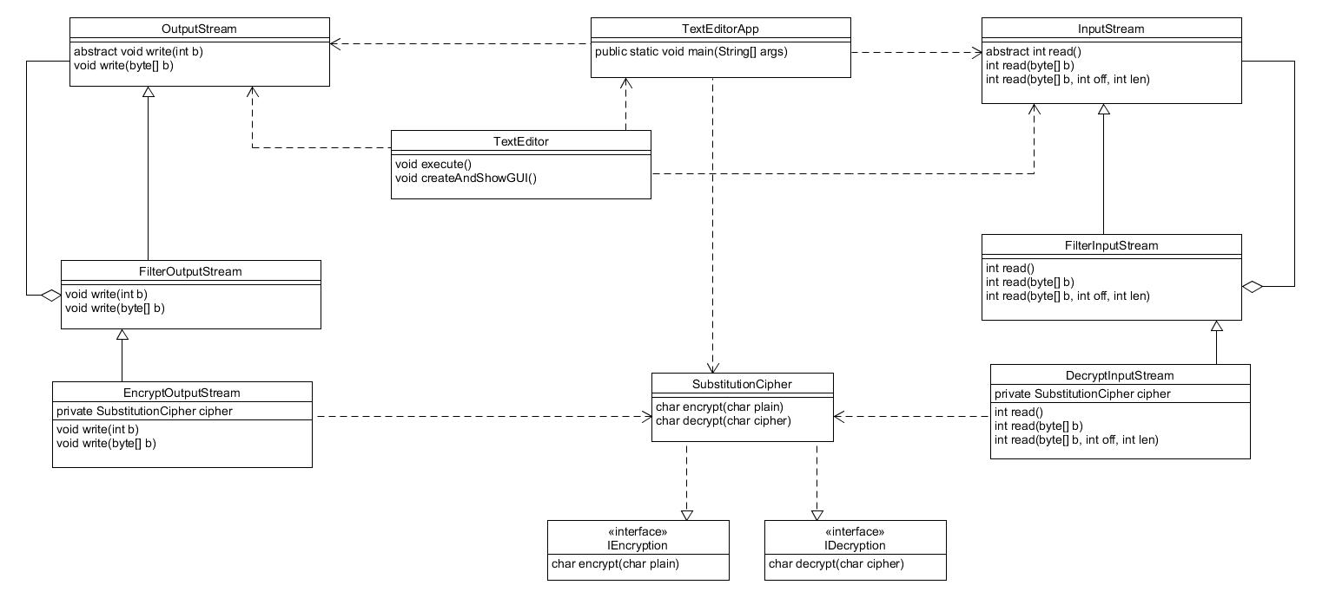

The TextEditorApp contains an InputStream and OutputStream which are decorated by the FilterInputStream and FilterOutputStream, respectively. FilterInputStream and FilterOutputStream are decorated by the DecryptInputStream and EncryptOutputStream, respectively. The DecryptInputStream decrypts the buffer it is reading and the EncryptOutputStream encrypts the buffer that it is given. A SubstitutionCipher is passed to the EncryptOutputStream and DecryptInputStream since, the SubstitutionCipher’s encrypt and decrypt methods can’t be called statically.